Racial Wealth Gap Learning Simulation Tracking Card



Please put your name on your assigned “race”


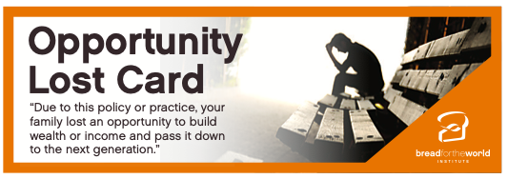
Return
Pick Up
Return
Pick Up
Return
Pick Up
With each policy that is read, each participant will be able to make an action: Money, Land, and Lost Opportunity. Your action is based on being “white” or “black.” Make a mark in the box based on what you are able to do based on your “race.” Please use a pencil.

